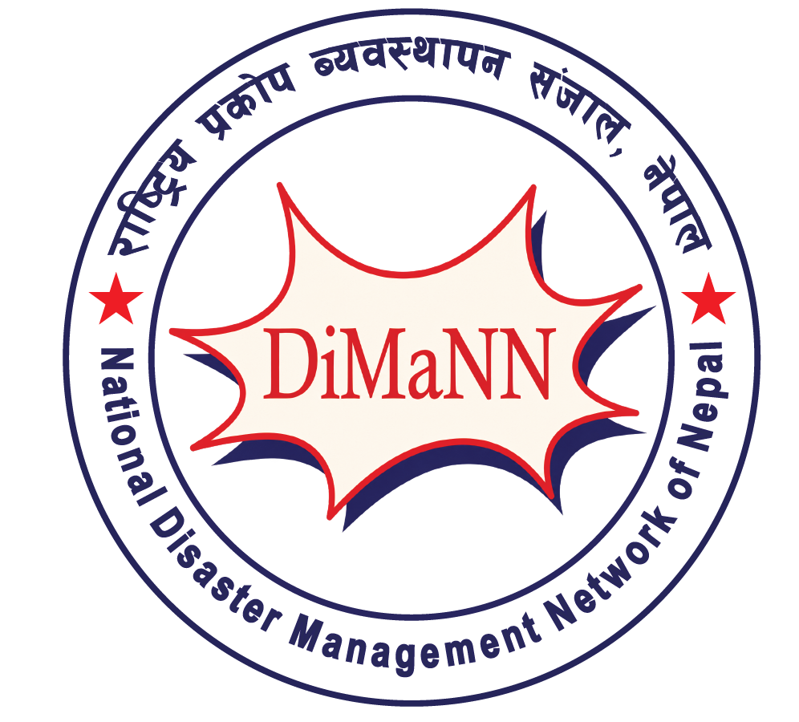
BRIDGE REACH ACTION-2
Civil Society Dialogue on the
Humanitarian Assistance, Quality, Accountability
and the Role of Civil Society Organizations in the
Rasuwa-Bhotekoshi Flood Response
NEED FOR COORDINATION AND COLLABORATION AMONG STAKEHOLDERS
FOR QUALITY AND EFFECTIVE HUMANITARIAN ACTION
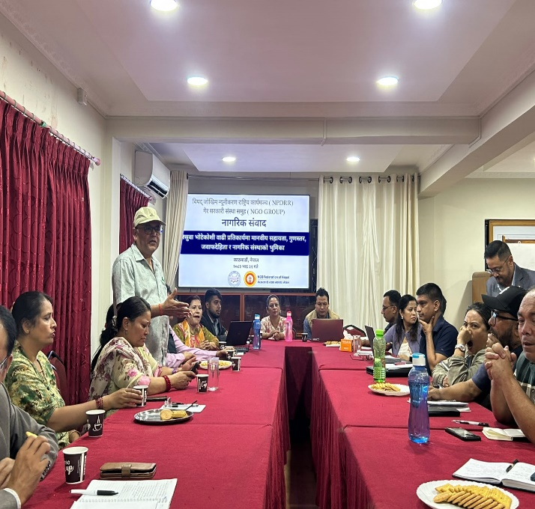
Kathmandu • 16 September 2026 (Bhadra 31)
Organized by the NGO Group under the National Platform for Disaster Risk Reduction (NPDRR),
with DiMaNN and NGO Federation of Nepal
Venue: NGO Federation of Nepal Office, Buddhanagar

1. Executive Message
The 2026 Rasuwa–Bhotekoshi flood response needs stronger convergence, coordination and collaboration among all stakeholders.
The civil society dialogue held on 16 September 2026 brought together approximately 50 organizations to reflect on rescue and relief efforts, identify gaps and define practical measures for stronger quality, accountability and coordination. The discussion connected immediate humanitarian needs with the longer pathway of recovery, rehabilitation and reconstruction.

THE MESSAGE FOR ALL STAKEHOLDERS
One coordinated response • shared information • quality standards • local leadership • accountability to affected people

FLOOD RESPONSE SNAPSHOT
Government of Nepal / NDRRMA operational update • 16 September 2026
INDICATOR | FIGURE | QUALIFICATION
People affected | 84,270 | Estimated • 6 districts
Children affected | 32,021 | Included in total
Persons with disabilities | 1,854 | Assessment figure*
Municipalities / districts | 17 / 6 | Assessment coverage*
Deaths / bodies recovered | 1,403 | 105 bodies handed over
People listed as missing | 6,150 | Verification ongoing
People rescued | 13,742 | Government operational figure
People in holding centres | 2,096 | 29 centres • Rasuwa, Nuwakot, Dhading
Source: MoF/NDRRMA Rasuwa–Bhotekoshi Flood Update Affected-population cross-check: UNICEF Nepal, 16 Sep 2026

Why a Coordinated Response Matters?
- Humanitarian actors need a common picture of who is providing what assistance, where, to how many families and through which mechanism.
- Relief quality must be assessed by relevance, dignity, protection, accessibility and accountability—not only by quantity.
- Sphere Standards and the Core Humanitarian Standard (CHS) need practical application, monitoring and context-sensitive implementation.
- Response and recovery must address the needs of older persons, pregnant and postpartum women, women, children and other vulnerable groups.
- Government, civil society, humanitarian partners, academia and local actors have complementary mandates, resources, knowledge and networks.

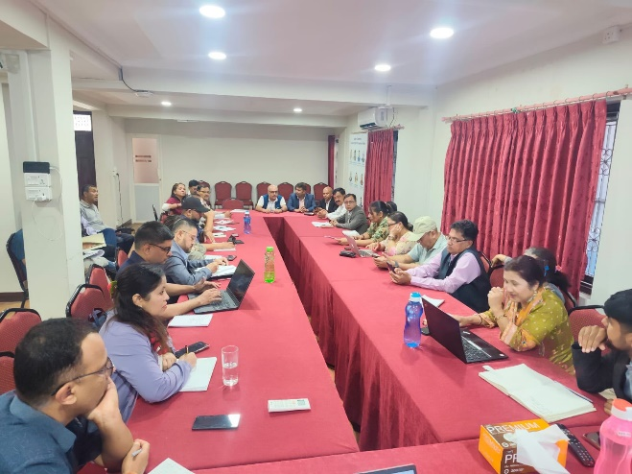
Figure 1. Stakeholders participating in the civil society dialogue on humanitarian assistance and the Rasuwa–Bhotekoshi flood response.

2. Dialogue Background and Leadership
The dialogue was organized by the NGO Group under the National Platform for Disaster Risk Reduction, with the involvement of DiMaNN and the NGO Federation of Nepal. Mr. Surya Bahadur Thapa, President of DiMaNN and the NGO Group, chaired the programme. Mr. Arjun Bhattarai, President of the NGO Federation of Nepal, delivered the welcome remarks and highlighted the objectives.
Dr. Sunita Sharma, Advisor to DiMaNN, presented on the Sphere Standards and Core Humanitarian Standards (CHS), including their application and importance. Mr. Shyam Sundar Gyawali, Advisor to DiMaNN, further clarified the standards and shared observations on their application during relief distribution, the quality of assistance, dignity of affected people and the role of civil society organizations.

3. What Participants Identified
- Coordination gaps — Local coordination and information-sharing need to be strengthened across government, civil society and humanitarian actors.
- Assistance mapping — A consolidated picture is needed of which organization is providing what support, to how many families, where and through which mechanism.
- Standards in practice — Organizations need stronger knowledge and practical capacity to apply Sphere Standards and CHS consistently.
- Data and evidence — Reliable data on displaced families and response coverage needs to be collected, maintained and shared.
- Protection and inclusion — Older persons, pregnant and postpartum women, women, children and other vulnerable groups require deliberate attention.
- Holding-centre conditions — The shortage of toilets at holding centres was highlighted as a dignity, health and protection concern.

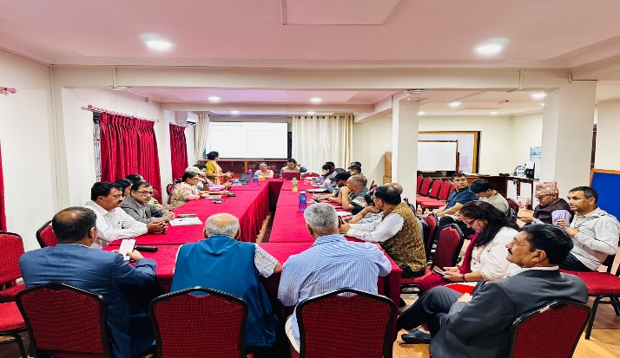
Figure 2. Participants reviewing humanitarian response experiences, information gaps and coordination priorities.

4. Quality, Accountability and Dignity Must Be Visible

“The continuing gaps in information, coordination and knowledge management are deeply concerning for effective relief and recovery. Equally important is ensuring that the voices and specific needs of survivors—particularly senior citizens and other vulnerable groups—are not lost in the response.”
— Mr. Rohit Kumar Yadav, Advisor to DiMaNN

Sphere Standards and CHS: from knowledge to practice

The dialogue emphasized that humanitarian standards are meaningful when they are understood, applied and monitored in actual relief operations. Participants called for stronger orientation and capacity-building, assessment of implementation challenges, and monitoring of relief distribution and other humanitarian action.

- Protect the dignity, safety and self-respect of affected people.
- Apply humanitarian standards consistently while adapting them appropriately to Nepal’s context. Mr. Surya Narayn Shrestha – Advisor of DiMaNN
- Strengthen safeguarding and ethical conduct across organizations and delivery mechanisms.
- Use monitoring, feedback and evidence to improve assistance during relief and recovery.
- During a disaster, collective action matters most. People affected by the crisis need relief, support and solidarity—not questions.” Mr. Gobinda Bdr Sahi

- Greater attention should be given to preserving the dignity, safety and self-respect of survivors throughout the response and recovery process – Netra …………………………………
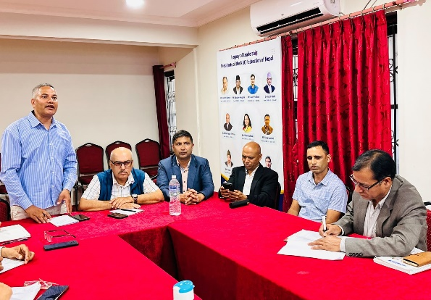
Figure 3. Dialogue participants discussing humanitarian standards, protection, accountability and ethical conduct.

Equity is a response principle

Equitable resource allocation and inclusion should remain priorities throughout rescue, relief, recovery, rehabilitation and reconstruction Mr Surya Bahadur Thapa – Chair Person of DiMaNN

5. Stakeholder Convergence Framework

The dialogue points to a shared framework in which different stakeholders contribute their distinct mandates, resources, knowledge and networks while working from a common information and accountability base.

Stakeholder group | Priority contribution
National / provincial / local government | Leadership, coordination, clear guidance, public systems, facilitation, resource allocation and oversight.
International governments & development partners | Financial and technical support aligned with identified needs and national/local priorities.
NGOs / INGOs / humanitarian organizations | Timely assistance, quality standards, protection, accountability, documentation and coordinated field delivery.
Donors & wider humanitarian actors | Flexible and sustained resources for relief, recovery, rehabilitation and reconstruction, with support for local systems.
Academia / researchers / knowledge institutions | Evidence, assessments, documentation, learning, standards research, data systems and capacity development.

The role of civil society organizations
- Serve as partners to government, providers of constructive feedback and channels for community voices.
- Contribute financial, material, technical, knowledge, skills and information support where appropriate.
- Maintain consolidated records of assistance and share relevant information with government and coordination mechanisms.
- Support policy dialogue, thematic groups and evidence-based recommendations. Mr. Arjun Bhattarai, President of the NGO Federation of Nepal,
- Prioritize qualified local people and local organizations in staffing and implementation, consistent with operational requirements.

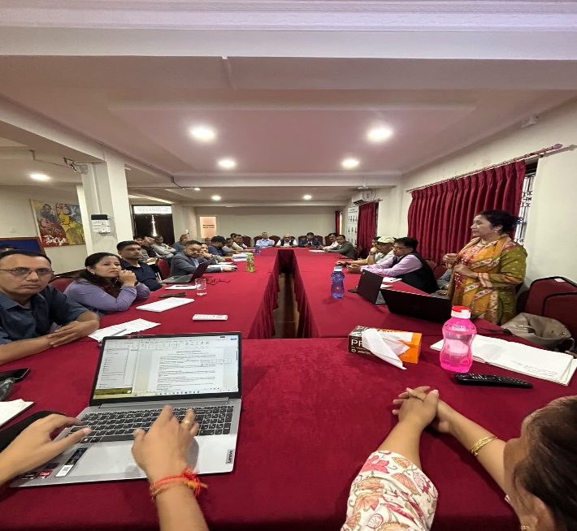
Figure 4. Civil society representatives and wider stakeholders exchanging perspectives for a more coordinated response.

6. Priority Action Agenda: From Relief to Recovery
01 | Create a shared information picture — Maintain a practical, regularly updated record of organizations, locations, assistance types, coverage and delivery mechanisms.
02 | Strengthen standards and monitoring — Build capacity on Sphere Standards and CHS and monitor whether they are applied in practice.
03 | Close geographic and population gaps — Identify underserved areas and groups and support timely, equitable and needs-based assistance.
04 | Put protection and inclusion at the centre — Integrate safeguarding, GEDSI and specific needs of older persons, women, children and other vulnerable groups.
05 | Address essential services at temporary sites — Track basic facilities, including adequate toilets and other requirements affecting dignity, safety and health. Ms . Geeta Subedi –Advisor DiMaNN
06 | Sustain recovery — Connect immediate relief with temporary shelter, livelihood recovery, rehabilitation and reconstruction.
07 | Clarify the one-door/one-window approach — Request written government clarification on what the system means and does not mean, while maintaining constructive civil society support.
08 | Localize the response — Strengthen local organizations, local staff, community knowledge and locally relevant approaches.
09 | Build evidence and learning — Strengthen databases, documentation, monitoring, policy learning and support for families of missing persons.
10 | Maintain regular convergence — Hold regular NGO Group meetings and thematic/cluster discussions and submit consolidated recommendations to government and NPDRR.
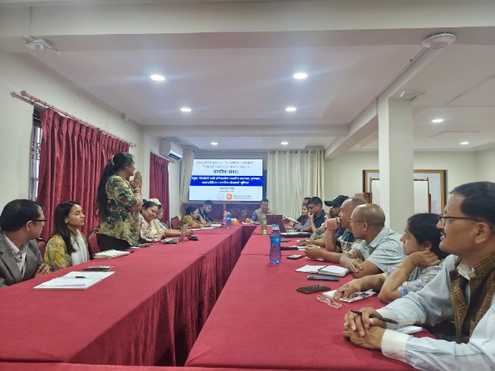
Figure 5. Stakeholders continuing discussion on coordinated humanitarian action, policy dialogue and recovery.

7. Conclusion
The Rasuwa–Bhotekoshi flood response requires convergence rather than parallel action. The civil society dialogue created a platform for organizations to share experiences, identify gaps and agree on practical priorities for quality, effective and environmentally responsible humanitarian action.
The central commitment is that humanitarian assistance should be timely, equitable, accountable, locally relevant, nature- and climate-sensitive, and coordinated, with the dignity and self-respect of affected communities protected throughout relief, recovery, rehabilitation and reconstruction. Mr ………… …………………………
Across all phases, response and recovery efforts should minimize environmental harm, protect natural resources and ecosystems, promote climate-resilient and nature-based solutions, and encourage environmentally sustainable practices in the planning and delivery of humanitarian assistance. This includes responsible management of relief materials and waste, protection of water sources and watersheds, and ensuring that reconstruction contributes to safer, greener and more resilient communities.
A SHARED RESPONSIBILITY
Government leadership + international solidarity + civil society capacity + academic knowledge + local expertise + community participation
8. Immediate Recommendations
- Compile the dialogue’s observations and recommendations and submit them through the National Platform for Disaster Risk Reduction.
- Continue regular policy discussions with subject-matter experts and thematic/cluster members.
- Mobilize national and international resources for recovery, rehabilitation and reconstruction of flood-affected communities.
- Maximize knowledge, skills and resources available within civil society organizations while facilitating access to additional resources where needed.
- Maintain a strong focus on information, coordination, quality standards, protection, inclusion, localization and accountability.
9. Closing
The programme concluded with appreciation to all participants for their contributions and participation. The dialogue reaffirmed the value of coordinated action among government, civil society, humanitarian and development partners, academia and other actors in building an effective and accountable response for affected communities.
Prepared as a convergence and communication version of the supplied Civil Society Dialogue report and accompanying event photographs.
Rasuwa Flood Devastation 2026: Humanitarian Action in Focus
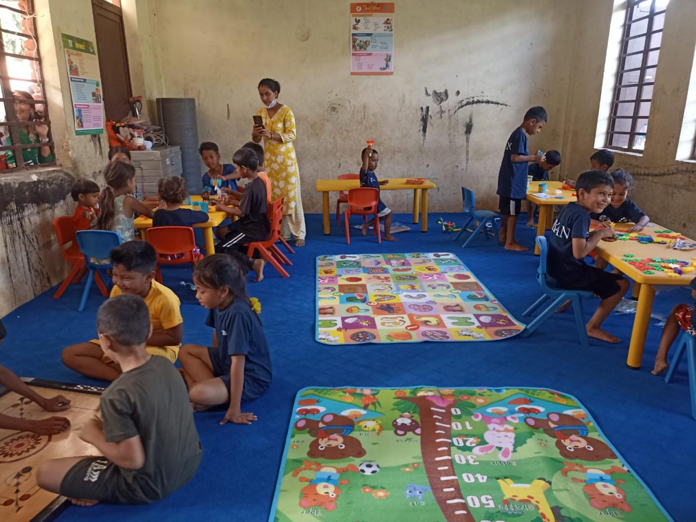 | 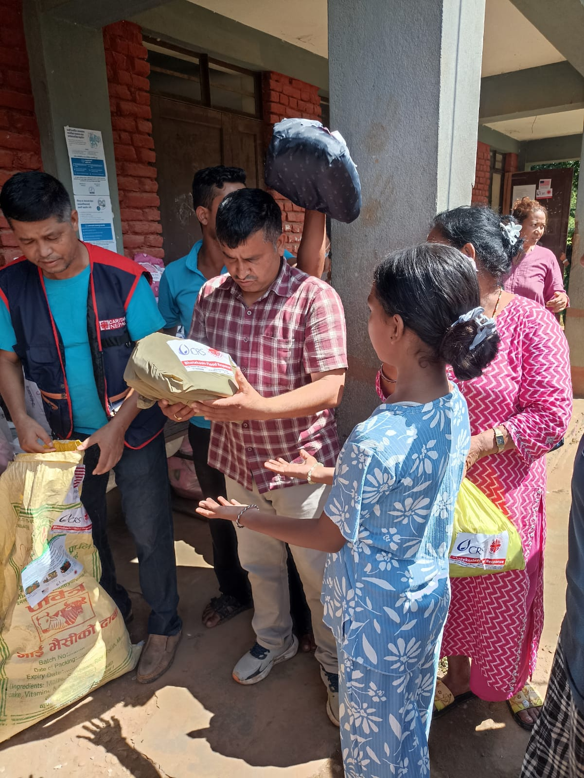
From Commitment to Action: DiMaNN Member CSN Responding in Nuwakot

3 | 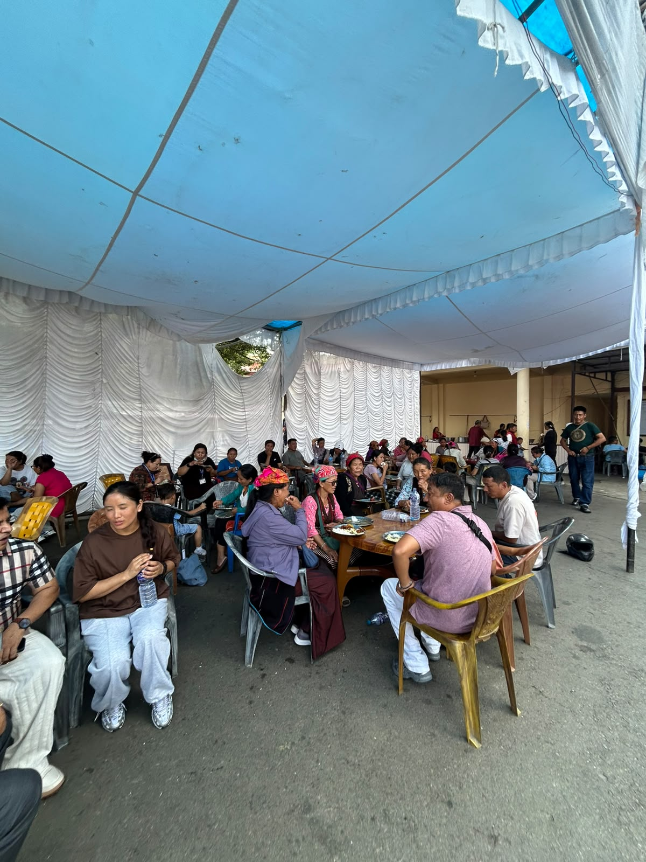
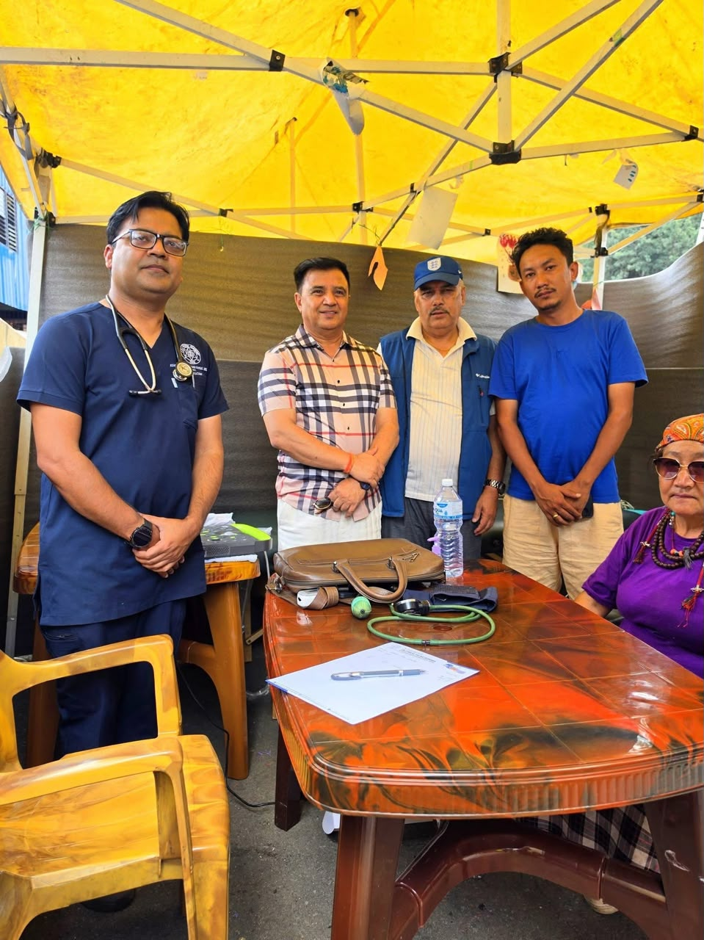 | 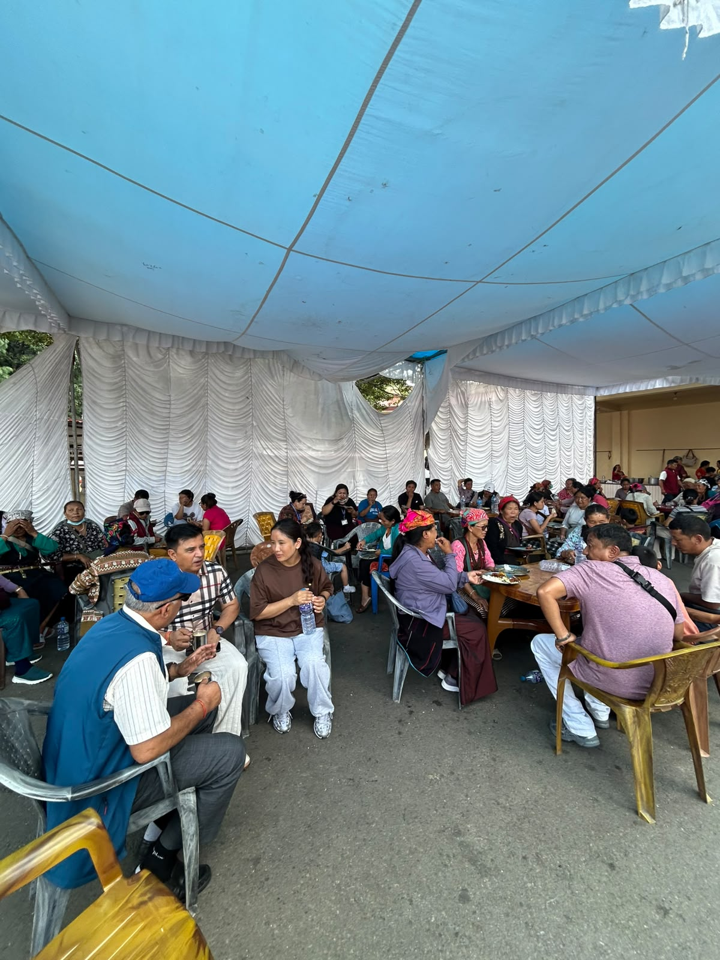
From Timure to Swayambhu: Listening to the Voices of Rasuwa’s Flood-Displaced Families — DiMaNN Field Visit

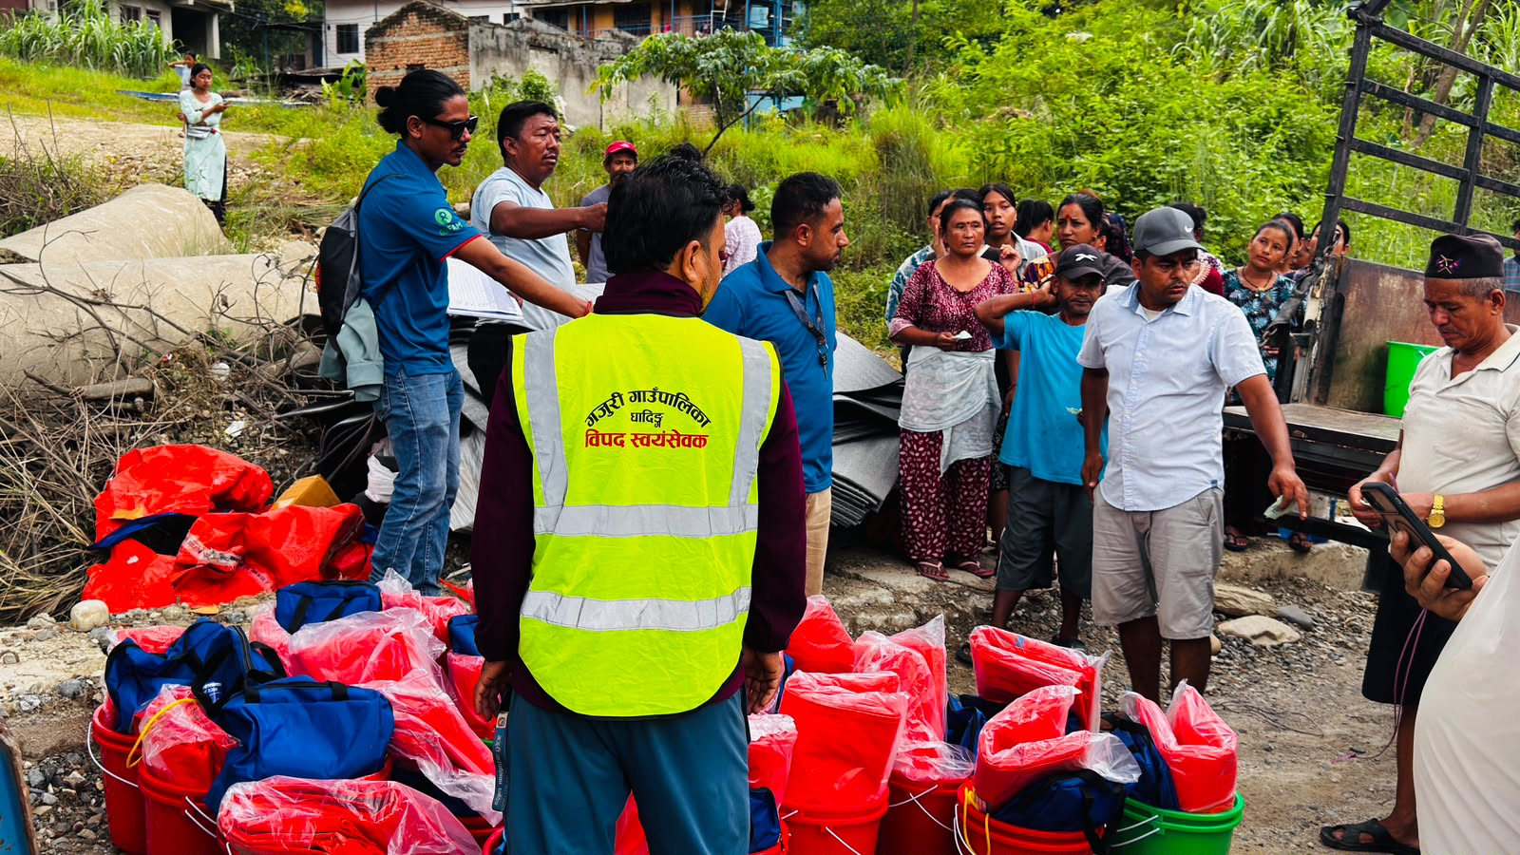 | 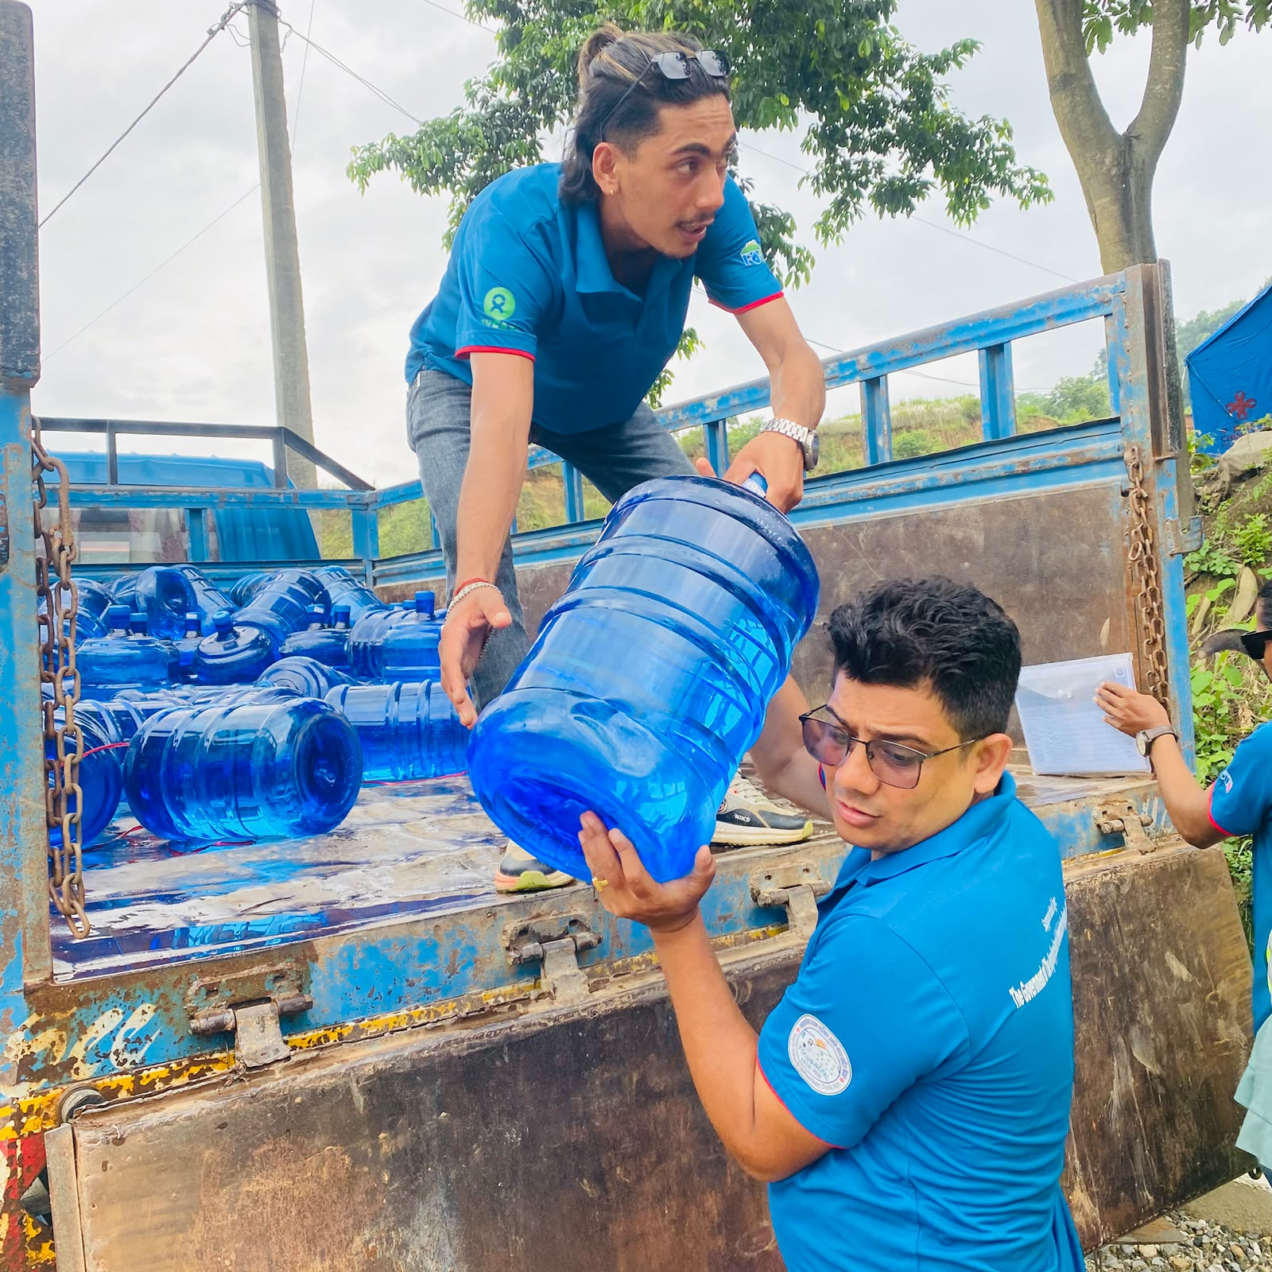
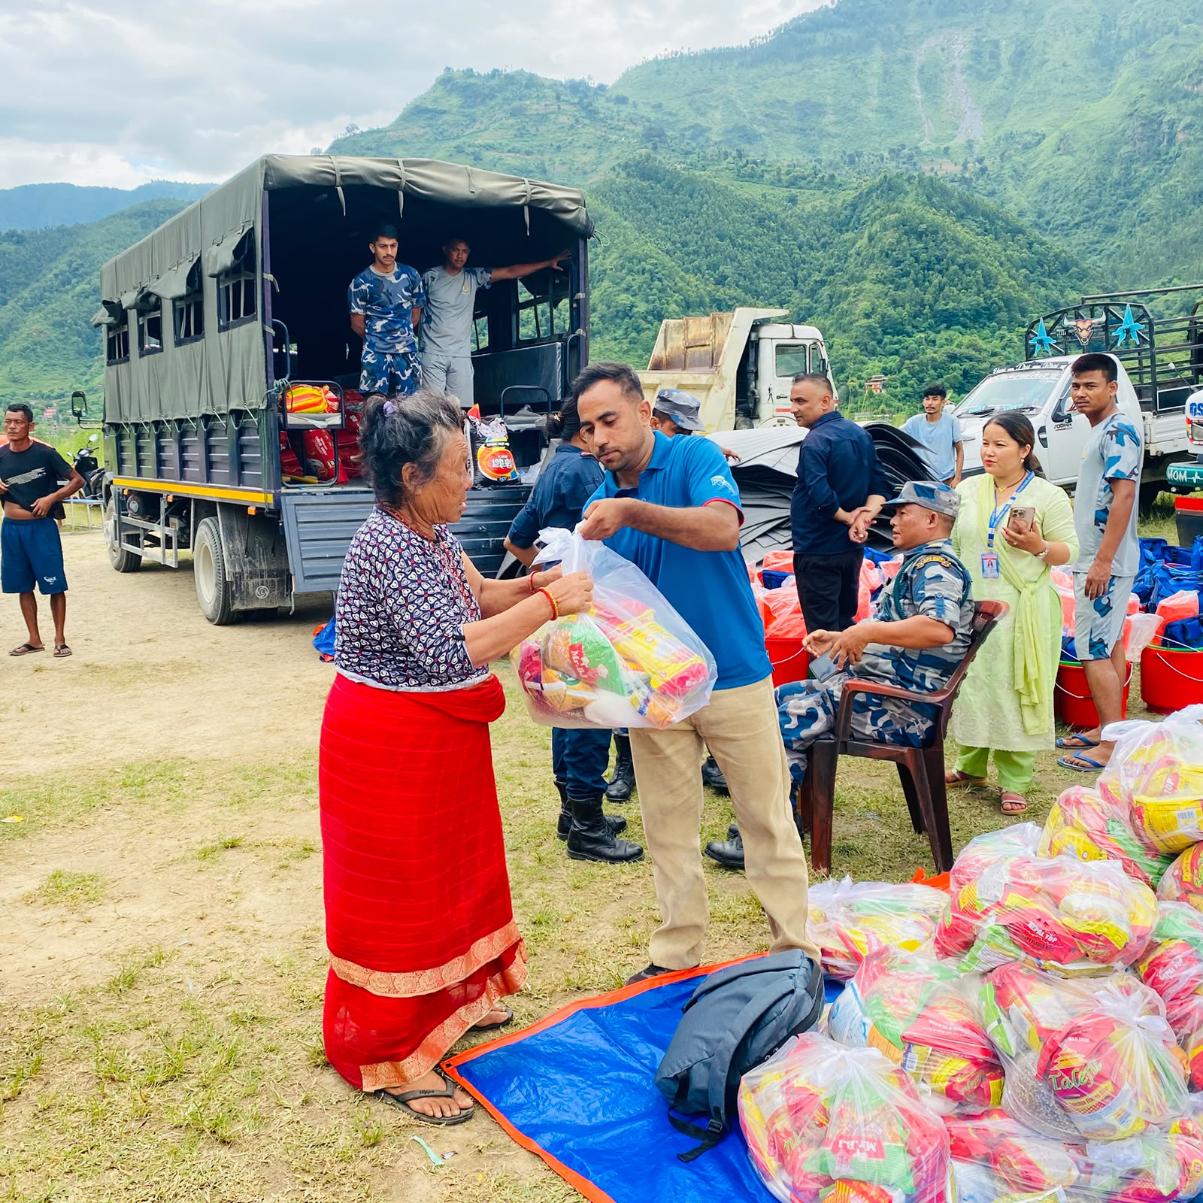
Community-Centred Humanitarian Action — Focus Nepal, DiMaNN Member, Dhading

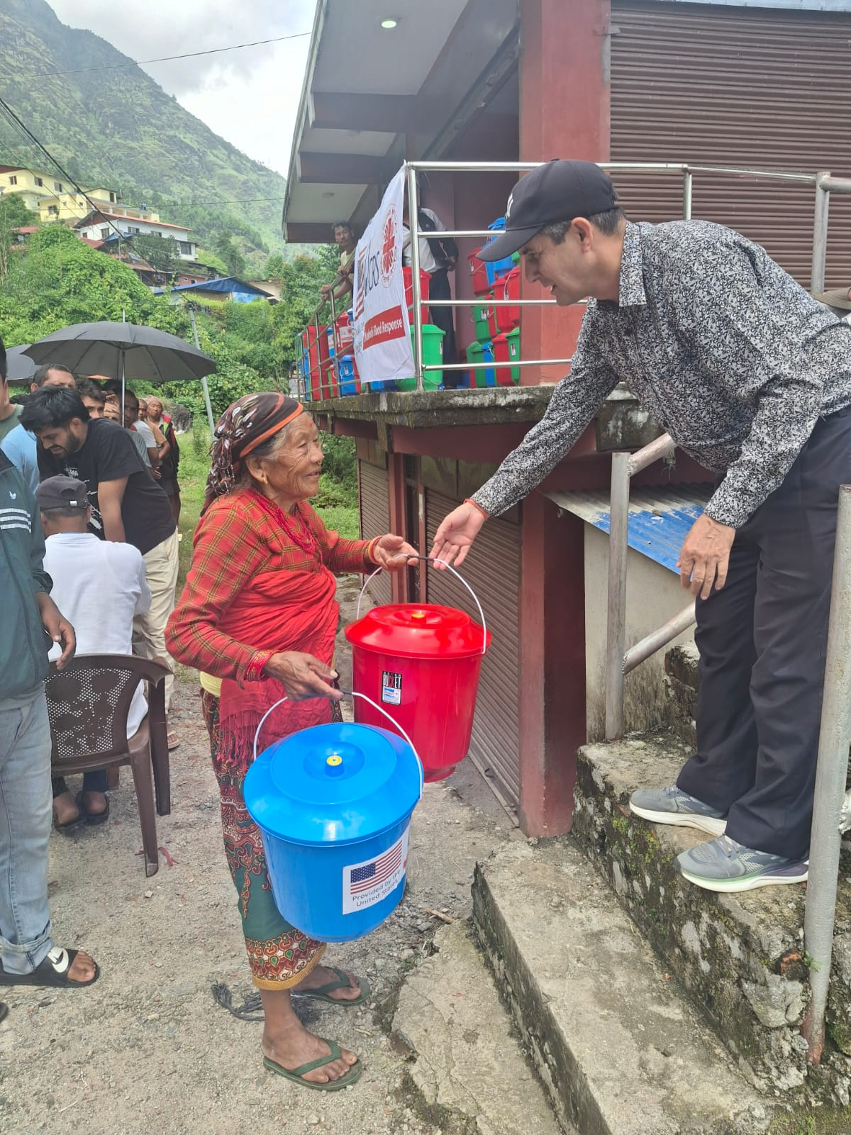 | 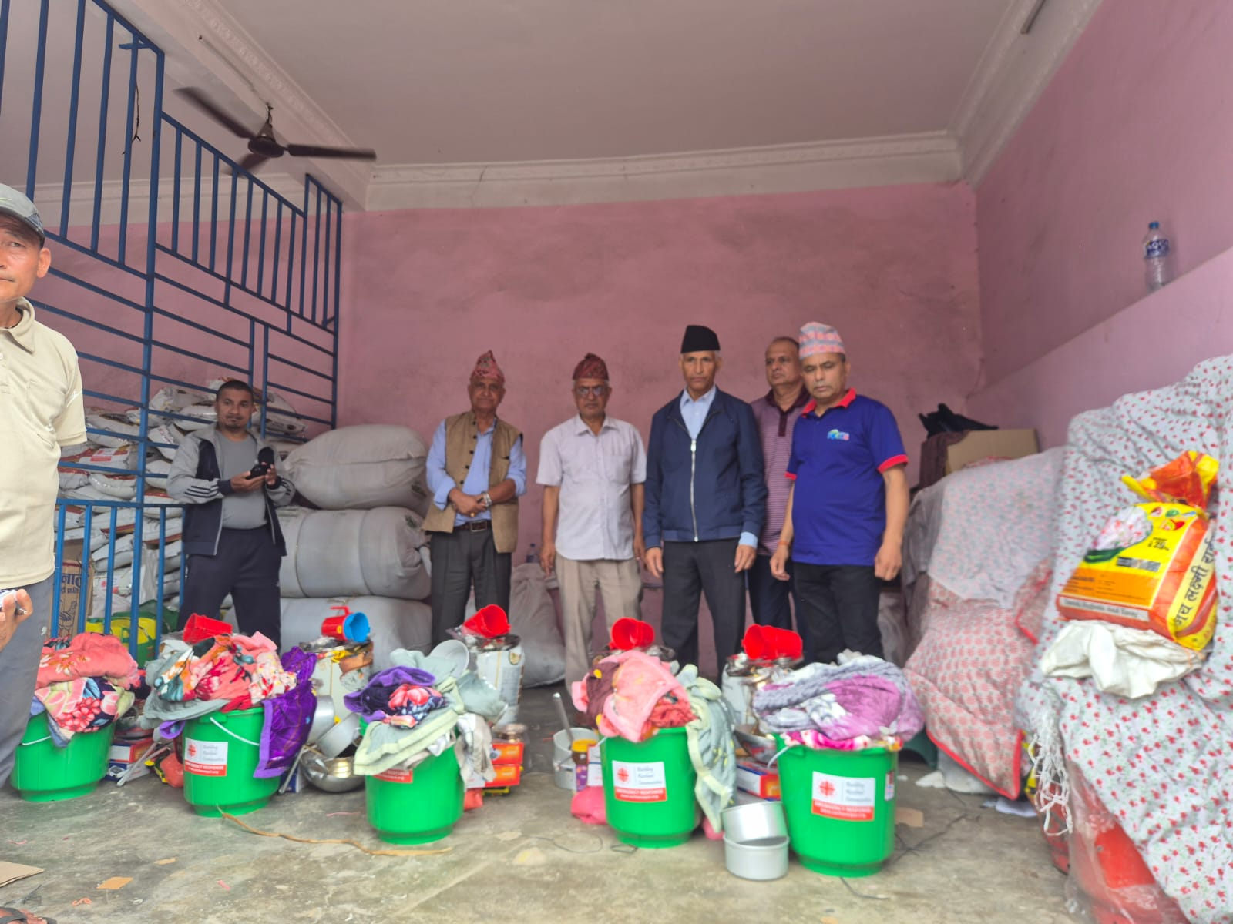
Standing with Families in Grief — Relief Package Distribution to Rasuwa Flood-Displaced Kriya Putri Families in Kathmandu

National Disaster Management Network Nepal (DiMaNN Nepal), Kathmandu, Nepal ,.Mahalaxmi-04, Imadol, Lalitpur
Contact No: + / +9779851098744, 5200319 S
Email: network.dimann@gmail.com / dimann@dimann.org.np

